JS Advanced Materials Laboratory

Experiment: Hall effect in p & n -type germanium

Related concepts
Semiconductor, band theory, forbidden zone, intrinsic conductivity, extrinsic conductivity, valence band, conduction band, Lorentz force, magnetic resistance, mobility, conductivity, band spacing, Hall coefficient

Principle
The resistivity and Hall voltage of a rectangular germanium sample are measured as a function of temperature and magnetic field. The band spacing, the specific conductivity, the type of charge carrier and the mobility of the charge carriers are determined from the measurements.

Experiments
1. The Hall voltage is measured at room temperature and constant magnetic field as a function of the control current and plotted on a graph (measurement without compensation for defect voltage).
2. The voltage across the sample is measured at room temperature and constant control current as a function of the magnetic induction B .
3. The voltage across the sample is measured at constant control current (B=0) as a function of the temperature. The band spacing of germanium is calculated from the measurements.

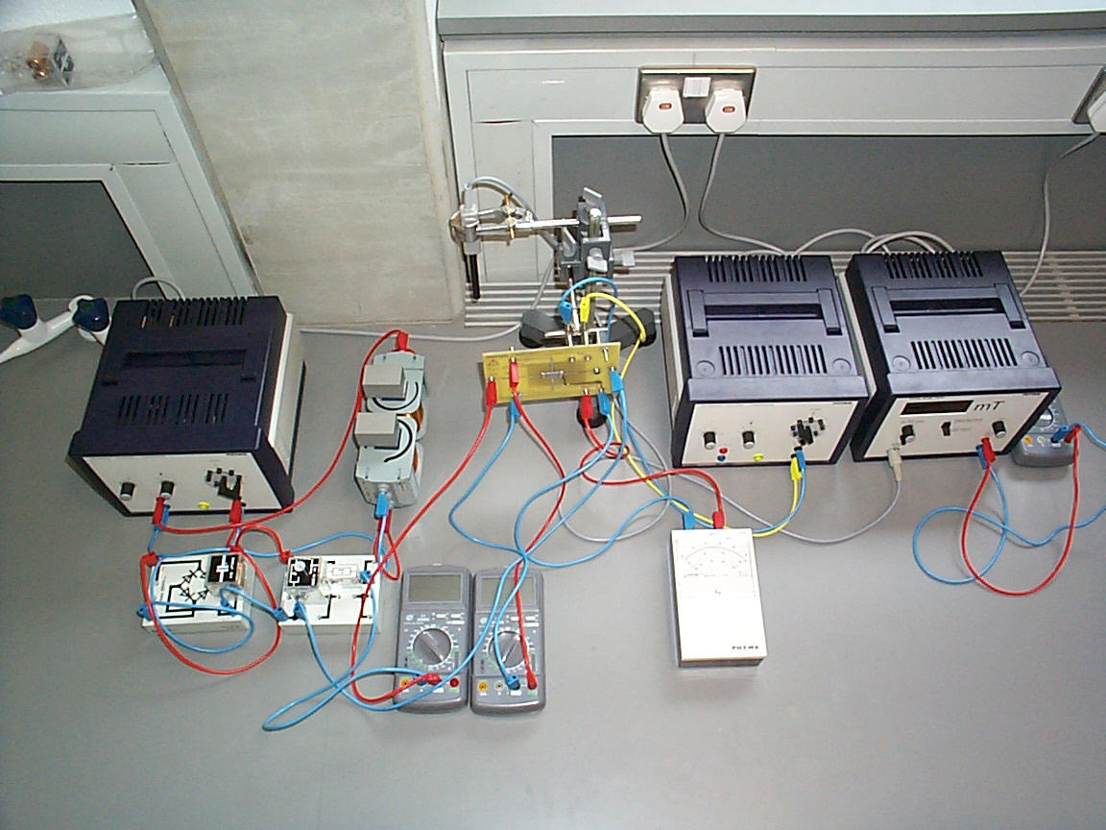

Fig. 1 Experimental set-up for measurements of Hall effect

4. The Hall voltage U_{H} is measured as a function of the magnetic induction B , at room temperature. The sign of the charge carriers and the Hall constant R_{H} together with the Hall mobility μ_{H} and the carrier concentration p are calculated from the measurements.
5. The Hall voltage U_{H} is measured as a function of temperature at constant magnetic induction B and the values are plotted on a graph.

Set-up and Procedure
The experimental set-up is shown in Fig. 1. The experiment has been partly set up for you, make sure you know what each component is for. See covering page.
When required, the plate must be brought down to the magnet very carefully, so as not to damage the crystal. In particular, avoid bending the plate. Keep values of the magnetic field to a maximum of 300 mT.

Experiment1. Carefully lower the plate into the magnetic field. Uncover the Hall probe and insert it into the positioning bore hole (6).
The magnetic field is produced by the two series-connected coils fed from the DC outlet of the main supply unit. It is advisable for this purpose to set the voltage to the maximum value and to adjust the magnetic field to the desired value by use of the current control knob. The power supply unit then acts as a constant-current source, so ensuring that temperature-induced resistance changes have no effect on the field strength.
The magnetic induction of the field is measured by the teslameter via the Hall probe which is placed near the centre of the field (after the apparatus has been adjusted). Set the field to 300 mT and set the module to read sample current Ip by pressing the selection switch (7). The sample current Ip should be set to zero using rotary knob (1). The Hall voltage Uh is measured by the high resistance digital multimeter (1) and this should be set to zero using rotary knob (8). The Hall voltage Uh is recorded as the sample current Ip is varied between
-30mA and +30mA , using rotary knob (1). Readings should be taken at regular intervals eg. every 2 mA

Experiment 2. Set the sample current Ip, to 30 mA using rotary knob (1) and carefully remove the plate from the magnetic field. Note the voltage across the sample from multimeter 2. Carefully replace the plate in the magnetic field and set the teslameter to 300 mT and note the voltage across the sample. Now record the voltage across the sample at regular intervals as the magnetic field is reduced from 300mT to zero or as low as possible.
The sample resistance in the absence of the magnetic field, R_{o}, is calculated and the change in resistance

(R_{B} –R_{o})/ R_{o}

is plotted as a function of the magnetic induction B (R_{B} = sample resistance with the magnetic field) .

Experiment 3. Remove the Hall Probe from between the poles and cover it. Move the p-type plate up also so that it is clear of the poles. Set the module to read temperature by pressing selection switch (7). The sample is heated to 150 ºC by pressing button (12) on the back of the module. Caution, the sample temperature must never rise above 170 ºC. When the temperature reaches 150 ºC switch off the heating by pressing button (12). Record the voltage across the sample (multimeter 2) at regular intervals eg every 5 ºC, as the temperature falls.

Experiment 4. Set the module to read sample current Ip (switch 7) and set Ip to 30 mA by using rotary knob (1). Set the Hall voltage Uh (meter 1) to zero by using rotary knob (8).
Carefully place the plate and the Hall probe in the magnetic field. Set the magnetic field to 300 mT. Reduce the magnetic field to 0 mT in increments of 20 and record the Hall voltage Uh at each reduction. Switch the polarity of the magnetic field by switching the leads at the power supply. Remove the plate from the magnetic field and zero the Hall voltage Uh using rotary knob (8). Replace the plate in the magnetic field and record the Hall voltage Uh as the magnetic field moves from –300 mT to 0 mT.

Experiment 5. Reverse the polarity on the power supply.
Carefully remove the plate from the magnetic field and set the Hall voltage to zero (rotary knob 8). Replace the plate in the magnetic field and set the magnetic field to 200 mT. Heat the plate to 100 oC by pressing button 12 on the back of the module.

N.B. The Hall probe should be removed and covered while the sample is being heated.
When the temperature reaches 100 oC switch off the heating and record the Hall voltage as the plate cools.

Theory and evaluation
If a current I flows through a conducting strip of rectangular section and if the strip is traversed by a magnetic field at right angles to the direction of the current, a voltage -the so-called Hall voltage -is produced between two superposed points on opposite sides of the strip.

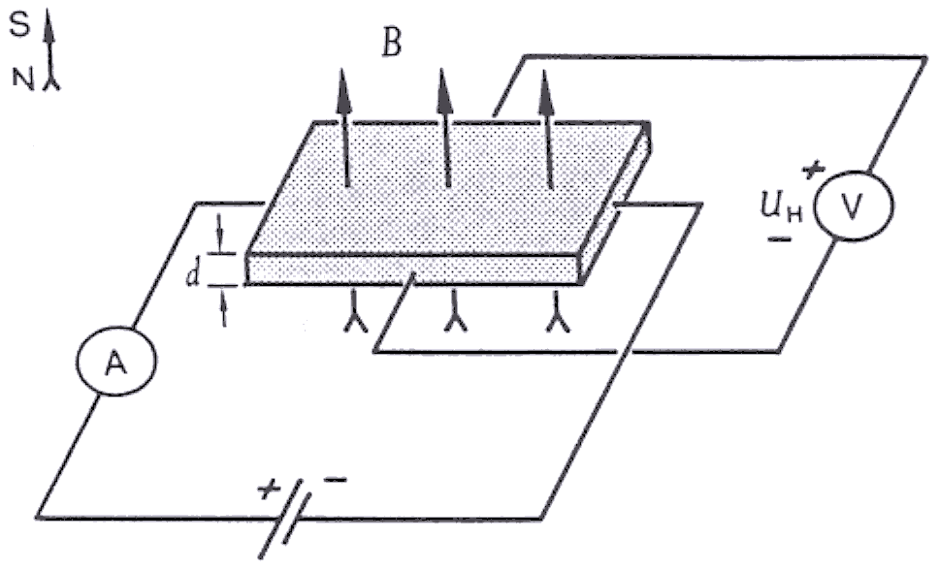
Fig. 3 Hall effect in sample of rectangular section. The polarity of the Hall voltage shown applies when the carriers are negatively charged

This phenomenon arises from the Lorentz force: the charge carriers giving rise to the current flowing through the sample are deflected in the magnetic field B as a function of their sign and their velocity v:

F=e(vxB)

(F= force acting on charge carriers , e= elementary charge).

The type of charge carrier causing the flow of current can be determined from the polarity of the Hall voltage, knowing the direction of the current and that of the magnetic field.

Experiment1. Fig. 4 shows that there is a linear relationship between the current I and the Hall voltage U_{H} :

U_{H}=α.I where α. = proportionality factor .

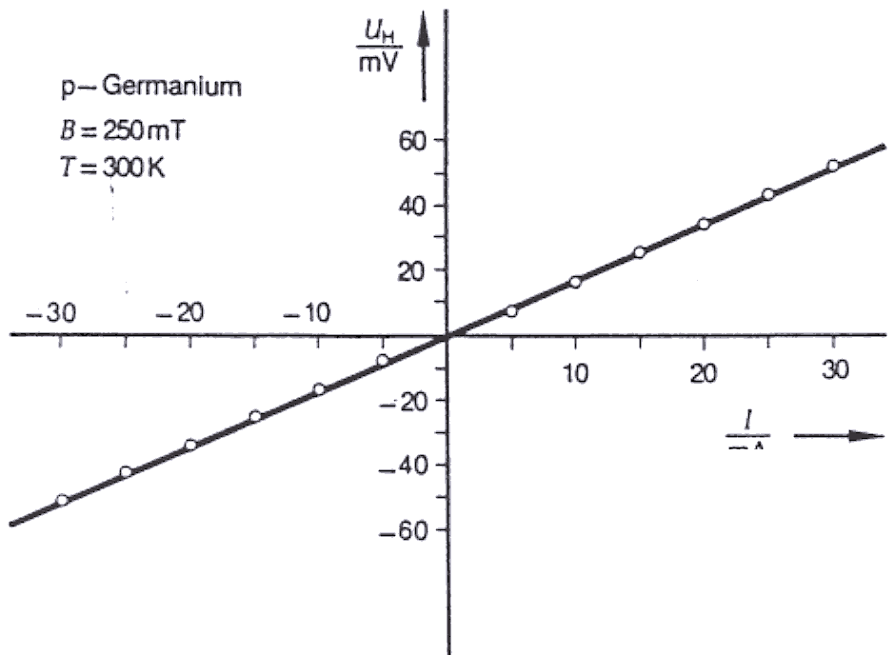
Fig. 4 Hall voltage as a function of current

Experiment 2. The change in resistance of the sample due to the magnetic field is associated with a reduction in the mean free path of the charge carriers. Fig. 5 shows the non-linear, clearly quadratic, change in resistance as the field strength increases.

Experiment 3. In the region of intrinsic conductivity, we have
$$σ=σ_{0}\text{exp}(−\frac{E_{g}}{2\text{kT}})$$
where σ= conductivity, E_{g}= energy of band gap, k= Boltzmann constant, T= absolute temperature.
Since the measurements were made with a constant current, we can put σ~ U⁻¹ , where U is the voltage across the sample. Draw a suitable graph to determine E_{g} in eV.

Experiment 4. With the directions of control current and magnetic field shown in
Fig. 3, the charge carriers giving rise to the current in the sample are deflected towards the front edge of the sample. Therefore, if (in an n-doped probe) electrons are the predominant charge carriers, the front edge will become negative, and, with hole conduction in a p-doped sample, positive.

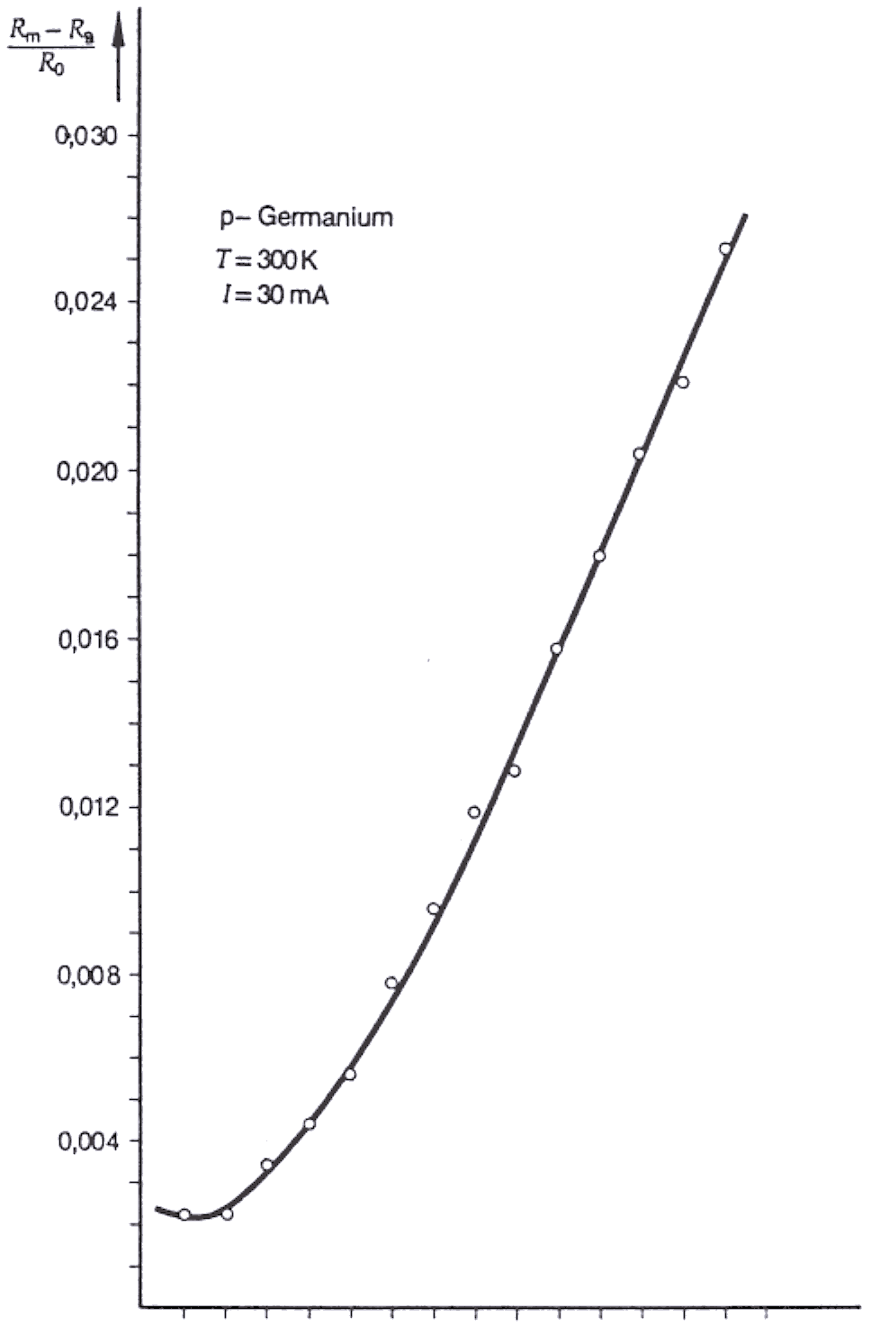
0 50 100 150 200 250
B(mT)

Fig. 5 Change of resistance as a function of magnetic induction

The conductivity σ_{o}, the charge- carrier mobility U_{H}, and the charge - carrier concentration p are related through the Hall constant R_{H}:

$$R_{H}=\frac{U_{H}}{B}\frac{d}{I} μ_{H}=R_{H}σ_{0} p=\frac{1}{{\text{eR}}_{H}}$$
Fig. 6 shows a linear connection between Hall voltage and B field. Determine the slope of your graph and from this determine R_{H} for a sample thickness d of 1 x 10⁻³ m and a current of 0.03A.

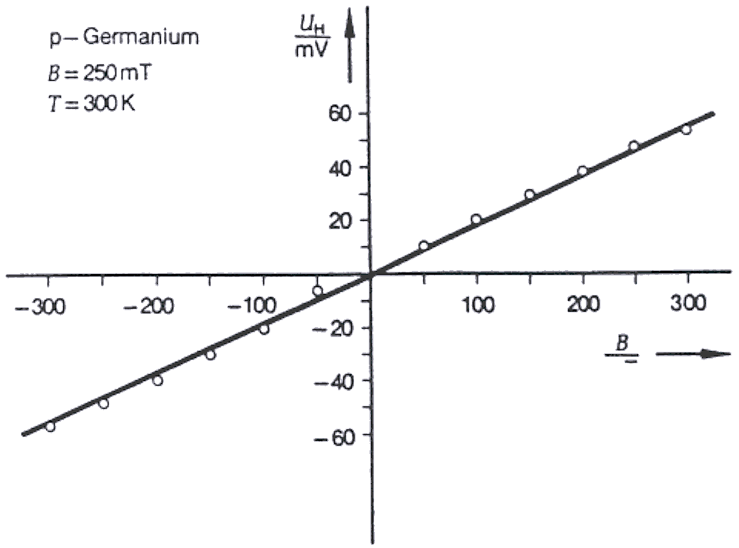
Fig. 6 Hall voltage as a function of magnetic induction

The conductivity at room temperature is calculated from the sample length , the sample cross-section A and the sample resistance R_{o} as follows:

$$σ_{0}=\frac{ℓ}{R_{0}\text{.}A}$$

With the measured values =0.02m, R_{o} calculated , A= 1 x 10⁻⁵ m determine σ₀.

The Hall mobility U_{H} of the charge carriers can now be determined from

$$μ_{H}=R_{H}\text{.}σ_{0}$$

Fig. 7 Hall Voltage as a function of temperature.

Experiment 5. Fig. 7 shows first a decrease in Hall voltage with rising temperature. Since the measurements were made with constant current, it is to be assumed that this is attributable to an increase in the number of charge carriers (transition from extrinsic conduction to intrinsic conduction) and the associated reduction in drift velocity v.
(Equal currents with increased numbers of charge carriers imply reduced drift velocity) .The drift velocity in turn is connected with the Hall voltage through the Lorentz force.
The current in the crystal is made up of both electron currents and hole currents

I= A e(v_{n}. n+v_{p}.p).

Since in the intrinsic velocity range the concentrations of holes p and of electrons n are approximately equal, those charge carriers will in the end make the greater contribution to the Hall effect which have the greater velocity or (since v= μ .E) the greater mobility.

Fig. 7 shows accordingly the reversal of sign of the Hall voltage, typical of p-type materials, above a particular temperature.

